Problem Statement 1:
1. Create a Java Application to Work with different collections - Arrays, Linked List, Double
Linked List and Circular Linked List.
1 a. Array Example
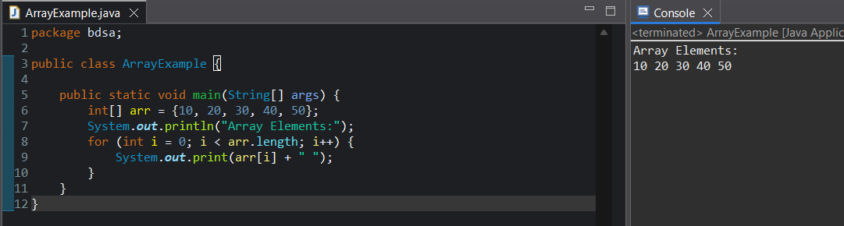
1 b. Singly Linked List
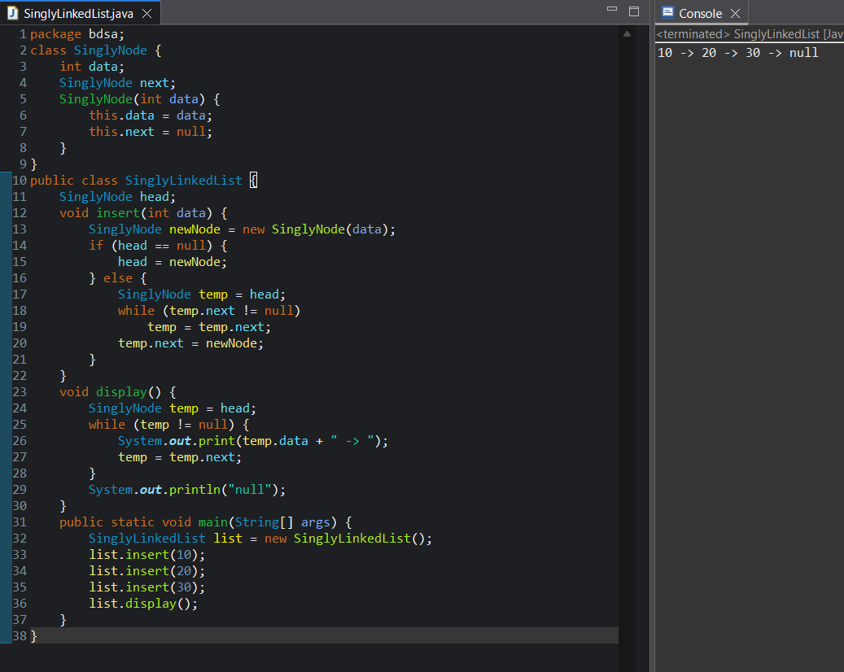

1 c. Doubly Linked List
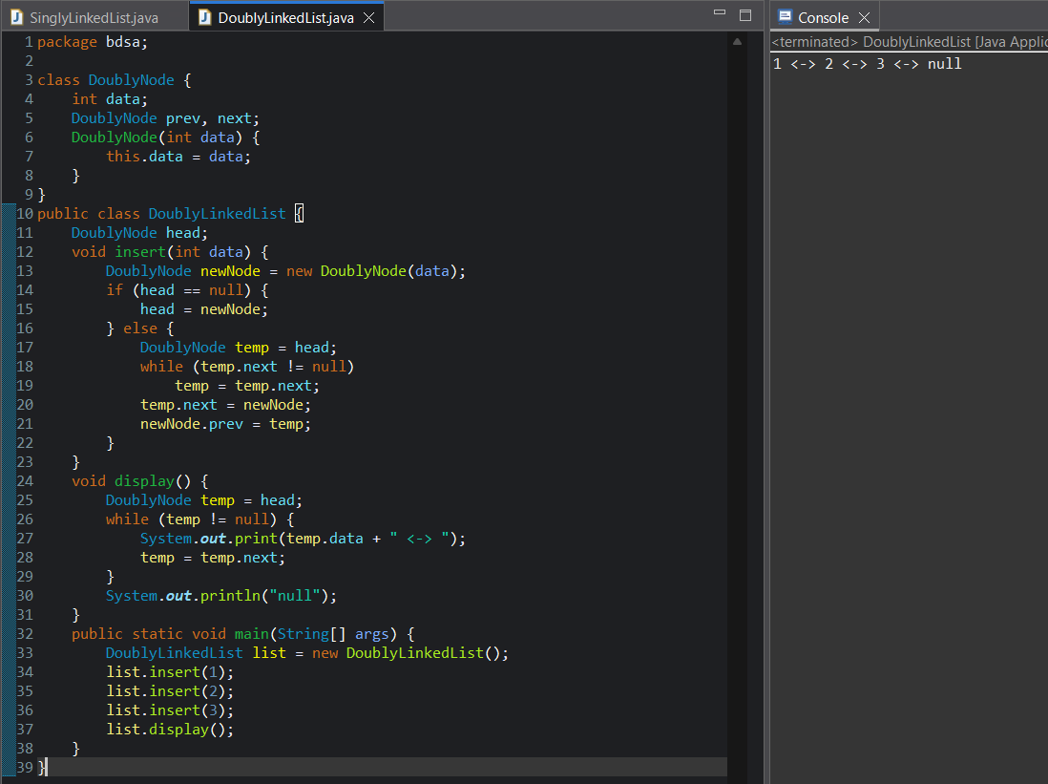

1 d. Circular Linked List
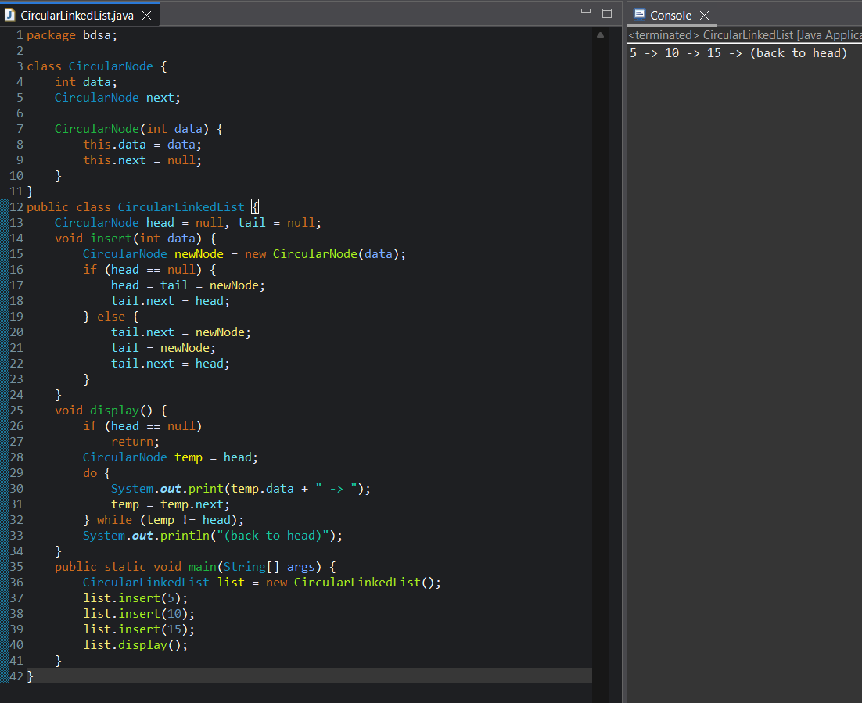
2. "Create a data structure two Stacks that represents two stacks. Implementation of two
Stacks should use only one array, i.e., both stacks should use the same array for storing
elements. Following functions must be supported by two Stacks.
push1(int x) -> pushes x to first stack
push2(int x) -> pushes x to second stack
pop1() -> pops an element from first stack and return the popped element.
pop2() -> pops an element from second stack and return the popped element".
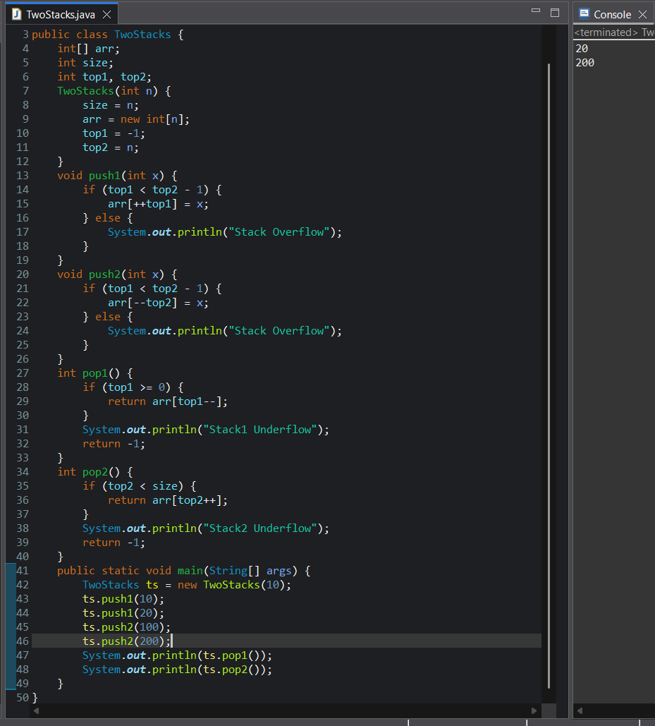

3. Write a Java Program to Perform Binary Search using Recursion
